B KISHORE

192110670

EXPERIMENT – 9

Functionalities of TCP/UTP.

Step - 1

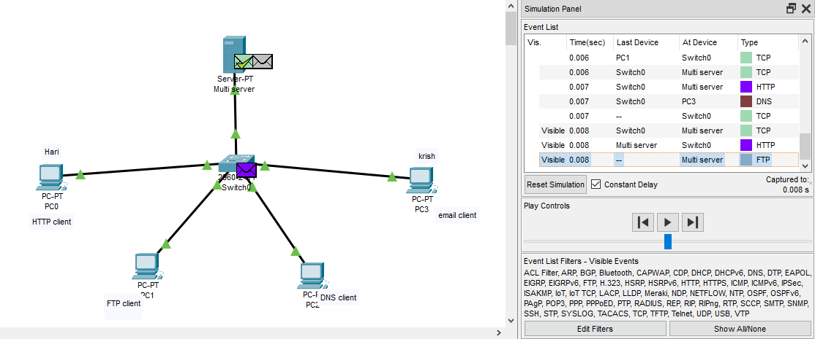

HTTP client:

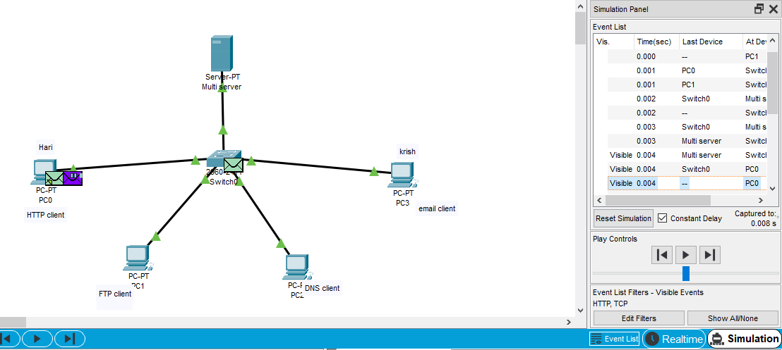

FTP traffic:

